
Timeline
Team GitHub: https://github.com/YeshwanthRam-03/Group-17-Project

Junaid Ahmad Noor (24158148)
Yeshwant Ram Kurala (24126775)
Raghul Shanmugaraja (24137957)
Eswar Repalle (24165064)
Dhanesh Kumar Reddy Chinta (24148688)
Prithvi Raj Madiwal (24148163)
Pavan Durga Venkata Satyanarayana Konduru (25000586)

Gantt Chart
Blue cells show the weeks when we work on each task, dark blue is our hybrid model, and red diamonds are submissions (approximate weeks can be changed with time or schedule) or milestones.
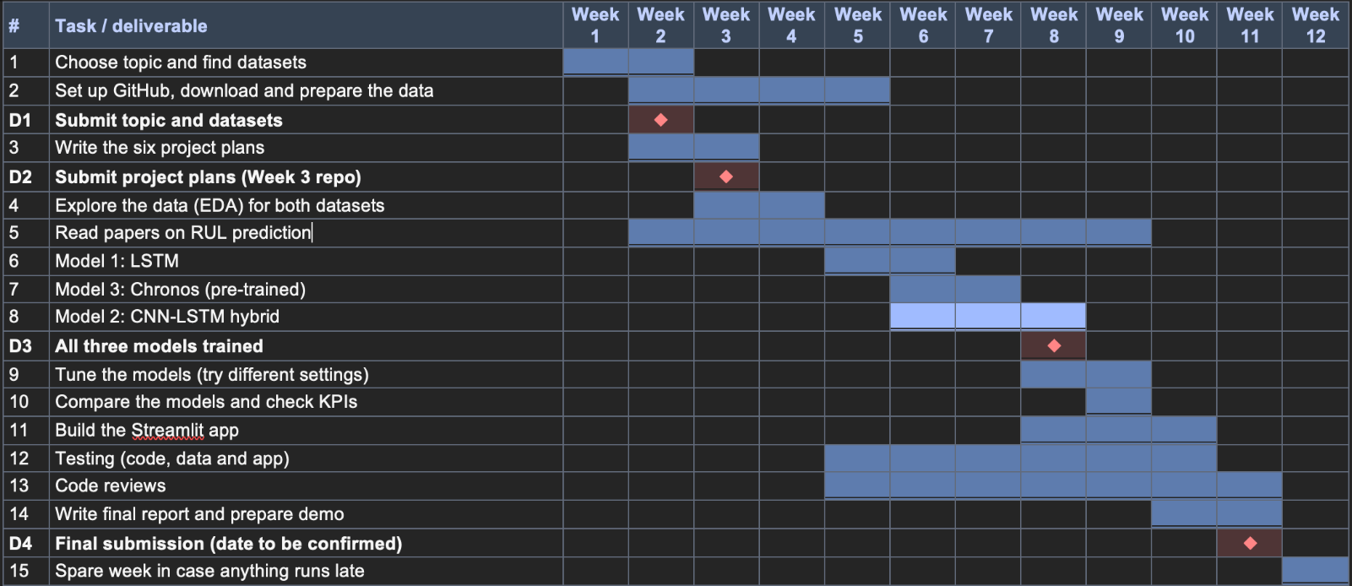

Deliverables and assessments
What we have to do or finish | When
Project topic and dataset links | Week 2
Six project plans | Week 3
All three trained models | Week 8
Final report with App | Week 11
Every date is assumption.

